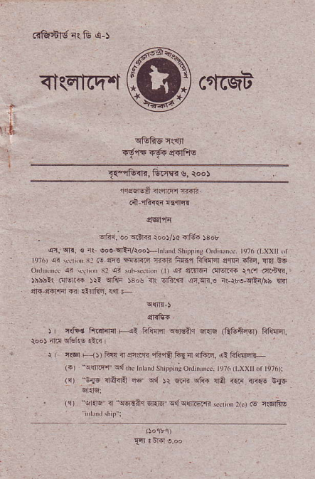
^{qI(Elt(["t crftqa} ffi cnffilv ai fu ,r-)
,, t_
'f6Ierl
. ?ta!. oo rmfi,oot5dot-. r8ot
^{qn, qr,} € _{r! eoe} ^{5n.r/roo)-tlt.dil} sLr pp rs onrinoN re76 ^{(r_xxlr} o ^{q?6) qi} \rdi I _{Nl F} ql- ^{]ml{!,e} 6fi Ff,iq &1iFt4 E"tF _{iftq,} ^{:Ira} Rs i!I!lrf{rq..lft.nR.
$b5?( aErii )rl oir"E r3"c m _{orft.r3} ^{qn.q|r.6} n!\F-qErAh ilir sri 3f6rfi fr .-Ida'r. rli +
qriGr
r cfqd tu irir4r Hi
_{Ffiffir} ^{q€rga{} s.q (Qffi{sr) FFERT.
r r@r F lJ) Fln4 sEni 4r,fA fua _{11r@.} ^{ql} fif!!'d'r _{l3r "c{]tFrf} ^{gd} rrc ^{r'irii(rsh} |)|):
^{'r} :..4 rffi .ri i_ @.- Fro (,1) ^{"6ir.q} i wlilq _{Er.lq} ^{q{q{nmR} $did ne f6 r{6rfrs
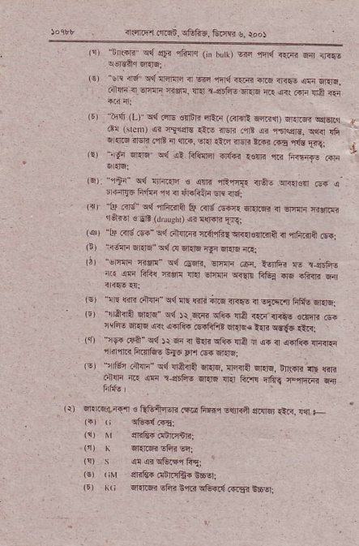
_{(!r "nrliF} ^{q{} sFr rFlr.r ^{(jn} b! _{o} ^{EF} fird R.ri @ <Frs
^{''sii {d r{ffi.ra} ir w rlr{ilR
r..iiari a orlnl Rsri!, lln r'grfiE _{sins} ^{q1} 61 aa6 u61 *o
^{''lr.ii} _{(L)} ^{q{} @lg €rlfir ilin ^{(c{ifi} _{64rr)} qelr6n qq-sTir ^{d!} _{Grem)} ^{ai nl1$E} iir6 ilw _{.rE} qi ^{,r5!aF. qiir {fi q|{@} .lqn .rfB m rni. ^{q{} {re rrsri ^{16 .F6 rds} Fgi t
_{le)} t€n ^{qliF} _{e{} ^{qi} f,ifc{rql ^{.r{{i} *m izi h?{iF ..ri
'!' ª _{Y-} ^{}d 'rra 6 ic} fl",-T r,? ! ^{{Fn@} F . d{n1T6 ii'fti _{1{l ir} ^{rir"liln qr} {61
^{(i} | ^{"l]r} _{R6"} ^{q{,ifi.jrR} Qt Rld.sr'ra dm.lri rr ffiF r{lrjai ^{'r€t€ €} _{Fti} ^{(dr} _{iush)} ^{qi q\r{E} ?q.
1@l'!r.{6.s-"q4Ghnrr!{lift{q.d€!flrir3",irftRril@i ^{(i)} _{"d!ln} q{r" qr1fl ^{qr{q ;rli} Etn6 i.ai
_{rrr} ^{"!E{rn} _{a!i!-} ^{q{} _{@.sE,} ^{EtEtq} @, Adfir E rrEB-s i( eF F&{ asi! rrrl 6t'nlr ^{q<!.fc} Ffu .ra rtuR w
^{(sl \lrq} fin r+{n c{ lir _{{jri} ^{qrFnJTf,o} ir E!..s.,r, _{fitu} qriqi (!) ^{rrdt{Et} 6Ers" c{ _{Jt.663} ^{q1i{ :t|A} r.ti'nrtE .inqri o{ ' i€lo !@ 4{ irlr6 _{Fdm ffi" e,li} qrf6,.Ri
(t ^{5l9i} _{Fi} ^{qd} rr E4 n Brii c8ft lra _{I} ^{qs} il {.rfts lli{lin r it{F ^{ft?lb! dr6} _{flr dFF} qr{&i
^{(rJ 1rfe4,} _{ciqlr"} ^{q{ llriErA} dlnq, _{{<{S} ^{q]rlq. En$n} ft r.inr _{n} ^{qF r-drfts} _{anq} ^{1llir} furl! fleq FraR
hfrE l
_{lr)} ^{ql.r.€irial !} _{QE.+fqi} ^{(F} _{r fiFr sl]r{a} ^{q.!l$} €c, {,,1 + li) _{ri} qFldFti
^{(r)} Nr $rnla{ daiiinrr:
⁽¹⁾ _{li} ^{qr.r@} EF<@;
(!) s .lI qiqEqcfui
^{(€r (^r} sRfrroffir!6srl
^{(r) ((;} Elnr6r -tii _{b,n'd} ^{qF{.{} 4Frtri E6sli
\ ;i,
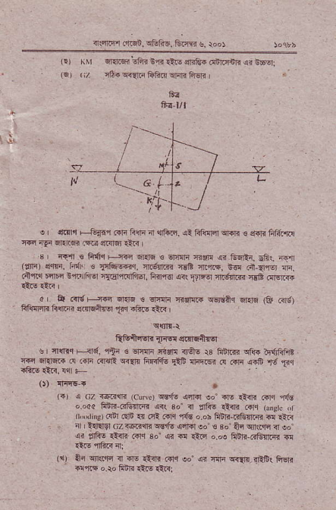
ir€]r'r _{.iijgin.} ^{qtuft5,} _{&qm} ^{g,} re)
lE) _{riLr} ^{q]qriq3} EFfr E{n _{1t-6} ^{qrift{} _{di]rq.nri} ^{qr} BsEr _{t€,,,/} 4&a$l]F ffi.q ^{lnl{} hlB
E6 t/l
e I d,ran F-.G{fi i+n liqr _{4 {Frc,} ^{q:} _{liliq4} ^{qi{i} € :l{a fitrFEq ^{'|{r} _{rlF lrrlrs} ^{(@} ctcrdr €4< I
^{'3} Rj r F{1q F,{rq €l{q € ^{q"4r} hnr sn E6Rr_ _{sfi.} ;rr![ ($rn el{'i, fid. ! _{{4fuwq.} ^{q.gffi} {sR nft'rc+, bq ri at6r {n, .{{q rlirr Eq.r rhEr il@trllffEr, ^{liirr<r s<l} _{?rrq} ft.6nm {€E r!16r.{{
_{0r} ^{q} ir]g F-:ffin {l{6 € srT{f{ 'nglaR ^{qsrlitq} _{6i<lq} ^{(E} .ild) _{tr{im h@'} ^{qq!-+{sl} _{F.} afte ,tr. I
Qtufrssn _{{rq} at{lEAigr
e | {{l..r F ir6, lli € €jrnF {i!'r! irqo 13 ^{Frnli{r '.r'r} _{wrl58+ d Fri ..14ft} ^{q{r* li{ifiq} liF 4rftEn e Rlr
o) I1rq6-r
_{li) s cz {q.?{r (cuv.)} ^{qs5IE qnrd eo'+ro} €.L @n I'ls o dd fER 6G{Fd ^{.srr} 34 { lrhs atii F1.r (rngtc ,t n.{rin!) dil .!jt rn _{oR .sre} ^{'rG} o or frfir-liliilrm d !-ir
. rl _{i{FM az r6.i{lr cE iE} ^{q4Fl} eo' € a"" +r wkrr a ed ^{ri} _{rfu} ^{,tr.} .6c 3o {id's.p"',5iicj!n-{a
€F iF <irl
^{(i)} _{ar} ^{qllldc ir ir-} €itr _{6F eq} ^{q<} _{fir} ^{q<{r1l_il:,F(} Fi6ri @iis o.ro fibR €N Q:.sl
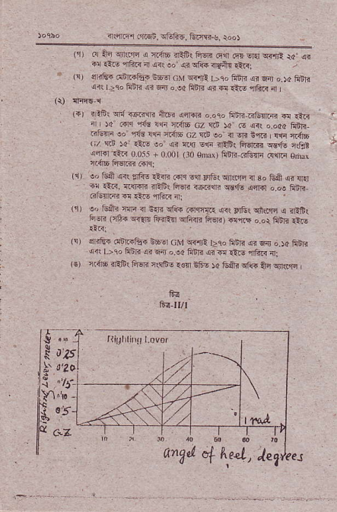
_{irnql.m.rn.} ^{qf;F6,} Ern{r{_ roo}
_{{r)} cr _{lti} qrkrli ^{q} r.ii6 r?St fi€r! e11 .q} _{ora} ^{q+]rt ia. si} _{d'.r1.} ^{*6F {} _i" to h t'e .€i rrc, ^{(!r)} e iFi ddr+fui EEq _{crJ} ^{q{,rji} bro fiili $ F4j o.)c ^{Fdi qil} _{Dk} hai !r F{ o _{e( FdE} ^{qn} d _{1iF} ^{qt{i} 4
^{({r} _{iFb!} ^{q{} T@rrR A.br ailm o oso 1$rr..jtnrs € ^{{ti '} il r4 _{r.lq} ^{,r€} i1! m4E cz Rn )4 c <( o.o4a ftfii _{.{rm !o'} ^{,r@} _{r:n r.ir6} (;z Ri !o,{ 6R nrrd !$i ci{b (;/ nE _{)a: r1ii eo'} ^{qi l.q E€} rlF< Fq.i? s{o llF,t
t
offarr-!r00j5+0001 ^{(:10} omm) Ffir ^{eltm.cftr} €trnr rim l-w"r .irl
^{(r)} _{!, Ei} qr{ ^{jthE} alnR _{..r{ ern} ^{p'ltu{qr{iq} rl s" fij& ar {r{ il {1ir, {$m nRF1 fuq. r'6iirr. _{w{e} ^{qrr{l} o.oa ftDR
F Fr n _{.:-o} ^{-5R} ,I.
ffi 16 _{.{tT.!F} ^{.d"} _{Fr.} {rrrF ^{4 €F! '.'1} !'t ^{r€E} _{tu.1!r r?c} *ec qmoo{Fai€r!
.!Ri
(!r siE ^{(InrFft-} E66r _{cM} ^{qflr?} t>eo hiti _{sr} ^{qri} o.)a frri ^{qi!} _{b 10 FDi an} ^{.f4} o.ea _{hnrfi} ^{qq} @ _{€r} ^{,r6ri} nl lE) n.ji6 .riii{ Fqr rstrg rsr 66- ); _{tu+i} ^{qi@} _{An} !rlr(.rE
Fr lllt
.. ?'
2s1
2dl
$⁰⁵I r'A anX& o[ ^{lt,e4,} tegeeJ
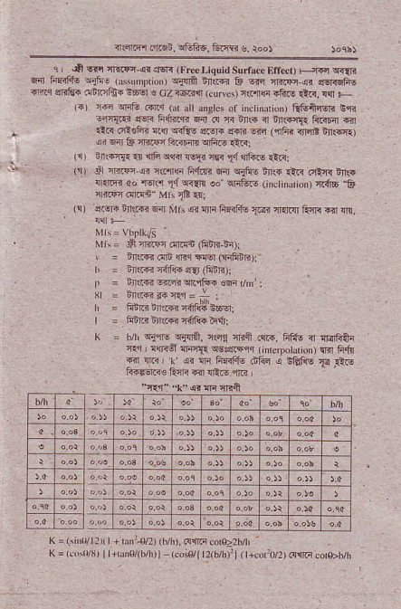
nsFr.4.5n, e6F6. l;.rB s_ root
_{I} ,E qfi rlr3@-(' ^{qsR (Frs} _{Liquid surtu.c |lllcc!) F{€r} q:r{li ^{qa} _{fiFaf.lo} ^{qdlo (N,} _{roriof)} ^{q{irfl ii.i@} F 6is riiiF e erqr{.dir r14r sI!E+ .rnftcfis iFE € ^{cZ T6riqr} kMws) {riqr rfir-s itii {ri F
lar _{rn} ^{qrnfo} _{lrt i} ^{(d} d Mctes ot ^{iDctindn} _{&6fr{6r!} i,r. ^{-n{.!n} e€F fr{f{4R 64r @ a rr{r fl ^{in$iI{} RRi4 6ir rlR otuhr _{'|s} ^{q<fiE} er.-r. ?rdB rii (qfii _{in} ^{jrt} ttj!r{.) ^{qi} 4ir _{E mi@ fto4n} ^{qrft-} !t3i
_{'.. f:."T.} ^{q} { P n6 r,I. ^{l€i} _{1:} ^{q'r6} .8r..
⁽¹⁾ s ffi ai l1riq _{fIlFi 5n} ^{qitus ni.i+} :tG .€fi nftq , { _{n !? 0d} ^{'M.l} _{tl} ^{q{la} _{oo'} ^{qti6.rs} {inc ituriotr) ^{r.4s} & i ffi iqF6" ^{MJi} _{lE} .:ri
^{(!)} er-ri ^{Elt$'i} +,n Mfs ^{@ lii Fraf+!} _{I@j} crfi{ licn F{r m,
Nr i= VbPlkJl
Mi\= _{S} riri.lli.irFd (Fin,EDr
\ ^{= rn(R} illn {jrq !{sl (FrFiE)i
h = dr..r{r rirft. ^{!f{} Giri)r
_{D} ^{= i,r.ii s"rs} cr.{1{ ^{6F} r/fi! i
, = FriR ir,..{n a4f#'c6drl
| = Frifti lirr.n {6lie itlil
K = _{b/h} qirE ^{qjrra,} ilc1 nrn .{.-. hftu ir najftai ^{qer} _{I rffi6l} ^{qrrF{r} wsgt4qq ( rturpol n,nrlfi.tu
g ^{rli,} _{I.} ai ^{m ffirs dfrE e iniis} 1i irq
_{"4F*. ti G} ^{qi.1} r
1l
::'
::
::
_{K =lirltllr(|+r} ^{'4l2) (h/h),} @!fti.od22h/h
_{K} ^{=(ro!l/f,} r+h0/(b/h)l- ^{(coi04} t2(b/tr:1(t+corr0/2) @$q cor$bnr
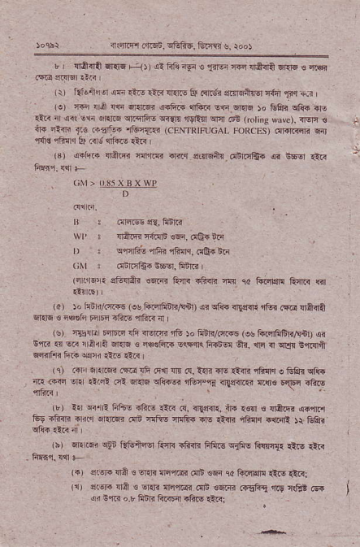
irsii'irr _{frFn_} ^{qEFE,} trr,r.r s, roos
r {ffii ^{ndi Fi{)} ₎ ^{ql} ftf{ {si ! _{firei ftq} ^{qa_da} _{4i{6 €} qrsi
^{(\)} tuieilili sF it& €F sr$s tu _{ffrg. s.nFnlq eF} ^{'rq} !,R ' _{lo)} ^{q..} _{lr.irl r1i 5r.16 4-firi} ^{qfii"} _{s.n} ^{q]riq} )o Frfrn c1i6 4]E :ir< { R _{ur 6inriBl} qriififro ^{q{ttr} _{'rqlfl} ^{qrir} ilt (rotirc wrre). irqn ! ^{@ 44fi} _{1,. .irlrt{} ^{'i6r{.i (cENTl{lFUcAL} FoRcEs) ^{i{rniiFrf< 4{J ,l{rd} rF{.r fu _{<r,,} ^{qriir} €e , (3) _{olGr} ^{qft.ft} rlrlm .rr.1 ^{qifilitu.dfinE! @ 66El} €r.
. ^{(;M} > o.$5 X BX WP
rr i .{r.N iE, Fqnr.i
wP | rrftB rfui €E|r, (16+ iii
_{r) :} ^{qq{6} aFB rFidr, mq. ir
(;Nr : di]r1Ei $EEr, ffiii
(qfl&. sE{A? €6ri! tuii rft{. w 10 i{i4m ftqr{ fil {!{16rr
(a) )o h E _{t:,rif.} (s_tu?rrhqr/qnl) .ei c1!.{ r{em. ifq ff@ llffi $qq 3 c{edl" rqF .hir, {i{c{ 4
($) n&{|i| FnEir rli iFqrF 4G ro ii r/mr. ^{(@} _{ffifr-nFb} qi B'rc {{ sG . _{raira} ^{ql.E} ts n@F|cr Eqrqrc fF or ffr, _{rt} q ^{qrer} imi ^{q{4lFR} _{ft&} ^{q$i} .iF ra.s I
rrj .€F Elr@ ^{(fe} Ift e{r !n @, _{lrltr} ^{qq} _{€{r4} ^{,i&{.r} e Ghq ca+ i1r t{ic vr. _{€..i? oit} q{6 qlifEi rftr",rd <'{:,fii..i !.{r€ _{\ftq} aftI!
(r) 11 €.|ri Ftu! sft- €R 4. <qnfi, in {€'1 € {rd.6 .4!'frcl _{tus iliiri .k.r} ^{qrn} 6i rfib nftE mji'{ lrs _{Lir.} ^{,ihqq} +rrq! )* G&t
ri) _{6l! ffi} ^{qln} ft&i{q kir{ _{rliilr frft*} ^{q{tuq} F!lr{. €is {ir F?sq. {{ -
_{lr)} ^{q46ri} {ra ! Enii liqc6lr.16 €F r4 ii.crffi {t{! {tii: (1) _{siqr} ^{q6} { €rrri {qq@ir oD €6.n Frf.5 n.9 rar @ ^{qi} t1ri o.r 6iri ^{FiiF{ i&F} €i<:
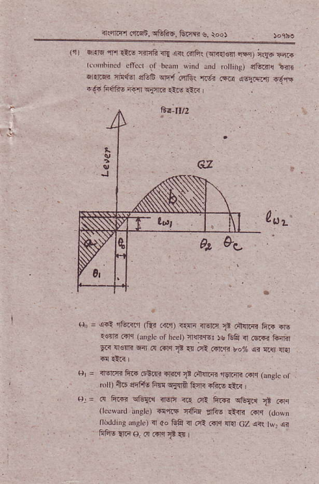
{$rF1 _{ar&n,} ^{q&niF,} Etl< s_ root
%
i1, _{s@} ^{'lY} _{5;.} ^{-.Fq} 1-n 4.s.{5. ^{@da"} ;rq6Fr t.or ifcd efind of bean wiid md ro iis) s6m{ nnrl 4 {ri6n {4qiar _{!!ffi} ^{qlf4;!1ei} r.di _{r6.n} ^{qa4q.,} .63{ ^{.644ttu-@ lq:4a} 4. ntd
q = a.l rc.{l (Rr .ffr) <.!n ^{rr6nr} ? d!|ii ftr drs r€rir .i1r ⁽ _{sle} or hcet) crcRqEr.s tu& I 6ri,-r tu{i
Frr 4qE Fir ^{.{ irr} _{e} {{ oi @riqn ro% atr fts lEr
i! ri.< |
_{H} ⁻ _{{ffi} ^{q.fi} 6r@ ^{ftic} Tt
, _{otD ii6 srft6 ftr.{} ^{qlllft} A.nl{ rfts €rR
_{or= i! rE@} ^{qrE{'1} lEn T(r.ct _{ftFi} ^{qtur.{ g} .nn ^{(lclvrd} _{Ers)} dq.i iitu riiE ri{n @"1 (dowD
r'rirddifs$sk) i oo &Q n .ri.irq 4{ a7 @( _{twr} qi
hFE!16e..4niq+41
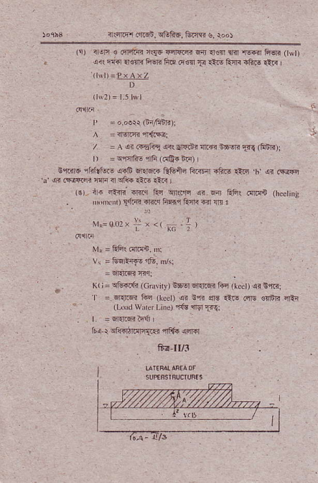
_{ir5F1r,fai,} ^{qtrF6,} &rffi s, rool
^{(!)} r !n € .qFflir4 nr{6 €4rqrn 6n _{{€!]l rhr} ^{!l6f.r} la6]n ( wt) _{r} ^{qir} F{{l {qR ^{Fw FF 6€!l} _{F} rt$ F{i rfts rtr l$l):PxArz
_{I} N2) ⁼ l5l\yl
_{t'} = o oeri (ii,6it?)i
^ =ren* {,4i"i:
, ⁻ _{a} .? .f5_.1 r+ _{5F6n} ^{:]@ !6F} _{Eq} ^{rhDln} ;
_{r) =} q,rqrft- erlF ^{(flt4} bii)
G,r.ir|6 _{rfalrls.E} ^{qsff 6FE ?} _{@irE} ^{li@r efir5} _{t{ii} ^{,h qi} 6cqq ^{,ci} .trrqi.ri rlln n ^{oli{} rlr- €r< i
_{(r)} ^{iir+} il<B'Frnr.r Ac wrlr sr @ Etir r!]i{B (hceri[! ^{. NN i)} _{!,l$i} rrnlr Ff,sl turi F4r {r :
^{Nrn=002r; x <(} re
Nr, = EF! idriln. i \'?6n t'e.n:
lr
. . K( r = ^{qtu-r{i} (Gtuliry) iF6:t fiqrq! tu ^{(r!d} ₎ ^{qr} s,rai '| = ErllrFr Fi (ked) @ nn $o rq.s crrs _{{r]n]i} qrtr (Loi _{wdci l-i'r)} ,r{g ^{rngr} Flr
. t. : Bir.lM?rni I
fri _{r} qftorri$qTll .iffu,rrlFr
S-d II/3
%
{.iiPr.f_ci. c1itrd. tum s. ro.r
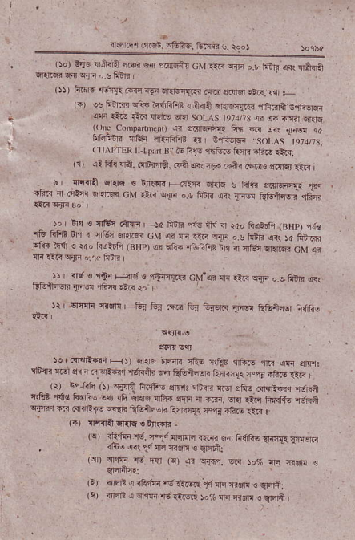
, lro ₎ R{!. 1 iH-EFr 6d eBl6fte _{cM liii} ^{q{n} , _{, hiri} ^{qis} ldtnir _{ffqrr w} ^{qrF} !.! ftitr
r5)) ln _{r&} ^{,req{} /,1,€ ^{-qi braFT!! .fii ofilq} €n, r$ _
^{(.J} _{!! hirm} ^{qlis} ?rlIftFE _{rriiia} ^{qnF{F} {FGrQ r,lF-srEn * ^{qD} €.,q at3 llarF st:d solAs t974lt3 si !n r|ti].sElq ^{,\'(.} n,t.J _{tr.{,} ^{.. :a@} f'x @ ^{i,} _{1re} r
| \"tu ^{t'6} @z r ;-r.-- ^{.,,t} _{\s} ,1-!.-,. _{r,} ⁽ tt^ ^{r'TtR t} _{fl,a} B" F Ffs 15fq- ^{&tF -fw} !ir<: . ^{(nr} _{sr F&} ^{qr8,} 6&ffF, FA orr r-@ ani rrq! erqq, it< |
h | {'mA sr,{E r nn(rn F--.rarr 6r.rq c frii ^{snn6q{ T.r} _{iftr} ^{q} ciinr B.rg- cM _{rti} ^{qlrq} , ^{g} _{ftir?} ^{q<!} 1J;@ _{ftF4,r€'<'} qr; _{..R} ^{qIF} 3o
ro hr € fl6, .,i{q F)d 5m ₄ ^{tt!} 4 ,oo ^{R4.d- ,nHn, re r'.} rtu !.r i r-s, ^{ffi} _{uV} ^{j" F 4} _{4tn} ^{,.e F6a !d,} _{)a} ^{nBi '} _{sre} ^{q+} . )." {i6dq,aHfi 44 _{rr@} ^{r -+Fs} _{o" I} ^{-€1Fi@ cM 1r $nI.Irr.In,:ni} FEr? _{-- ^i)} | d s nii F3.1€ ^{clrqFqq} cM'a? lri rts ^{qri} oofilR ^{@( 5f4nry} _{{r b} ^{-tE} ,rn :o
€R
)r I ^{Erclli} flfi F-&i Fa ^{.% fu:I} fu-llr T@ @4:rsr hdF t, .@tdr ^{-,} .4 ffi {., F?B ^{er-@} @ 4h r,
^{!'iie} E di,. _{:,r"''ec} ^{.rd<Fr @} !lE--q _{mdl{,} ^{--t} ri, ,tn _{, -'r:} G" k- ,) 'lll? ^{rn+,} sFrs itEc r., s,n,..rari4r r'-F,
_{"(En} ^{-,In} @.! e{ F _{;ra} ^{q,e} s i ^{q.. q} *i" ^{,.r.. , .r.a qri{} _{rii <rirEfc} ^{qqR} etut{6r? turi,rF ?ln Ftu- rni I (i) finQqi{E s!n({rj -
(q) _{rFtui} ^{'rc.} ry14 ^{nnlid} _{"rFr} E I ^{F66rs} lrF{{ TrEr.r
, ^{rEr- o<} _{Tt{q} nrsF ! qlrti:
(qt) _{ernTr} ^{'d} EaJ (q) .si ^{q.F1.} 6ir )o% lrn n${ s fflE
(r) rrc.E _{s iE 61} ^{'l; r!i-$.r} _{11lrc} iidn € qliril
Itr inlrE < ^{qs,rr} its.i )o% !n ^{nri !} _{Wni} I
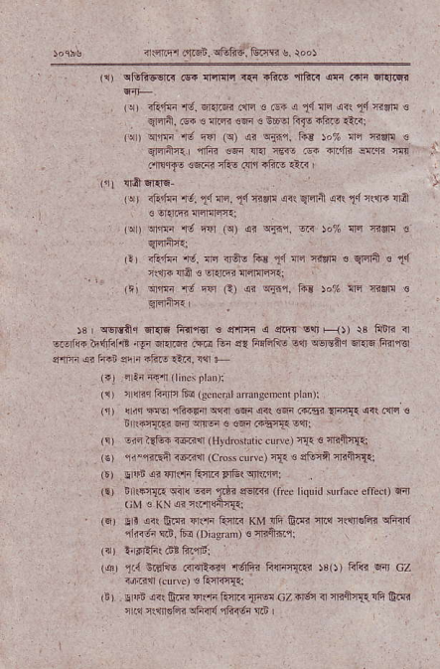
irqrq'l _{dr6n.} Eitrfrq, &?m $. rod
_{lr)} ^{qlnftwrq} _{@ flnan {{i 4&.s} ^{'llfi!_{ qr} ffi 6l{.R
(qr _{i1if6'd.} ^{qr.l 6i.!n €.5{ o} _{tl} ^{qrn} ai!,1,1n$i{ ! ^{grfli.} .5. ! {m €F ! n6cl tu{E rto- €ri:
(jr n16 t6 r-ln _{(q) otr} ^{qia'i-} iid )o% rra aflr! € _{E-} ^{+fP} _{@ rr} '€@ _{.F} dt rr w- m
.'m.Tt o!n??5 _{dr} 4?e drn
,1. cri ffi-
(u) ^{rfi'ri r.t,} _{tl} ^{in.} _{tl} Trffi _{<<( qldft} ^{q<!} _{tI{1'+} lla € ^{q{rfi} lErlllqri
_{(!r)} ^{qlrF} rJ FFr (9 _{sr} ^{qjnr.} c )o% ali fisF €
_{lrr} iEfF'd, ^{ni ir+s F{} _{tl} ^{qc} _{crv! €} ^{qlEri €} 1!l r!@qa€qi-r:nlir;nft.
_{lti or'in} ^{'6 qq} _{G)} qr ^{qinr.} ftd ro% ni nor! €
_{Js I} ^{qsNaq} 6r{16 ffirr{r € _{dtFr} ^{q q@} E!3 Fl, r3 fttn a _{c.6f6 hd,hf.E} .rgr ^{qr.lM} .@ tr{ s{ ffinFE _{lqr} ^{q€rsir.r} 6'l{6 FlnnEr _{:J'iF} ^{qi} _{ftii} ^{gi} i ^{itu!} _{tii.} !{r +
_{l4)} iinia:4ririneip!an)i
(r) ^{:raF.rEnrc Fq} _{GcNdl} ^{dintrscmc'r} _{d} )l
' !d4q+drnt6o@i
ir $i{a e;B $FF s €w .rsl{. o1rr
^{(s) -int{G-i@rn} _{{Hydrcsdiccr\r)} rn€ fiiqrla
_{(€)} ^{'r{-L.Efr} rr6.irn (cro$ ctrr€) rF c atu{ff ll.al{r
^{(rr} _{cr$6} ^{qi} {lrrF _{Eq1R FrEr} qnri'rii
(a) tr (fjfn ^{qiri @} _{Ttr} er6rr{n (rre _{liqtrid sunrce erred)} qil (;M . KN si rrcfldlT{.;
' ier sr, {s! trffi nr'ir R4e KM !& G.f4 iriq rernoFn cfr-n{ _{rliirt} ^{q.n.} 6r (Diisn,n) € nnftfl1
^{(q)} _{1{i} 6Fls _{Gr{Riir} ^{'l6rfrr} liqrr{F. )3()) _{ffii} ^{qr'} cz . i@{ (.u' ve) e l1'nT4t1i
^{(i)} _{*Fd} ^{q(} tm {r...ln ^{F4,n} {@ az r5r!3 iclilh{. !fi Gra _{rrtq ?$neFi} ^{qh<rd} ffin6 siD I
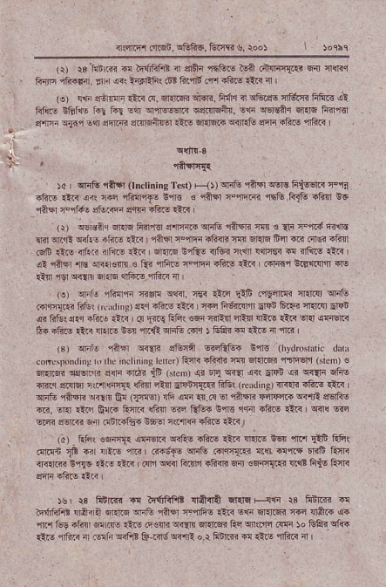
{({Fr ^{oli6} . ^{qli&6.} E.T{r s. \oo)
(r) _{i8't$rm} ^{q} tq6ftFB _{{ elffi} ^{qECrE} d .n4.n{< 6a afil _{Fnr,I} ^{qliiln} . !r _{r} ^{q<!} _{i-rdift .Bt 6'.{E !'n} ^{.!6is} €F a I (o) nli efirFfr rirr _{c,} qftrl5? ri@i. ^{F} _{"i ir} ^{qeL,fs} _{41tu3 hftr} qt trre cfrtft i"i hr _{Eqr} ^{qr'i-EEr.i qs.rMft{.} _{lri} ^{qstsar qFrs} iirrr€r q-4Er ^{q{i1} lqr srfi.fi silrsn&r €F _{Er{tF} ^{qfirtu} s'ri _{4fti} ^{qlftr} r
' rnElT{{
_{rcr} ^{qlrtu ran} _{0n.rining lest) F{,} ^{qie} _{"iftd} w:t FiGt< F'tr aft- riii all ]1fi rfilr'rt- ift € ^{ra]{l T,fift4r fi6} _{fttr} a6!l sE €tl rqii6 !e@ s{F rF.! d,|r '
(!) _{wrsii,} ^{qr{lq} _{liir'r<r s'[Fr{} ^{qnG} _{"iAFi} m . !F F1r{ ir.n _{Eli1} ^{qr.r! qiLs} itsrs _{€ti} ^{,insr} F,nFi rftaF rT{ srarg fra {|a .{Er -hnl cS !i.! aftd i Fn€ 1tF _{I} ^{q'{r€i} i1ts! <r6i tllrl !qF€< @ rfiirs .i.< | ^{(l} _{riilr} ^{'llo} sR. €rfr ! ,? nnnr; s4qr .fiF Ln rilTi! Ers{.{f dE _{tfl} ^{q9r q4} 6 6 iliiF afti a
1!) oFIo rfiFni Rsln rrir, r€:{ tic _{dii ."r{drm fi.nqr} qrE c{q{..n hto! _{| \ {rinE)} rEr .tos €F L ]ffi F6.n$ Elan fti?i cr{Rl slci R lif€t sflcr iitu €a ^{' R} _{fi-} Fft {qi rnrt$ EE{ {EiE _{€R} q{ q:l'FF b. -fcs _{riF} ^{.r.} 16 _{ter} 'llcfi ^{qFG} rdr ) _{ltft} ^{q} lliE d {6i
_{(s)} qrl€ qit\$r ^{qflF} _{effil} ^{qrcEGF} i,it (hyd'ondic ddr _{cor'.,rnnlils} ^{(,} rlir irdLtr )s ldrc, firlr aFiF _{m 611116?} ^{'r6lF6rjJ} _{Grem)} ts _{silr@} ^{qf6(!ri} ellri irdi _{iG {n.h)} qi _{E]r} ^{q{{ q(} sr4n _{an} ^{q{{ri} sFE 6Ra eflr6 _{r{r,r €i{. {Frir} ^{q:?} Er4n Flrr G&! _{{rul|drng)} {<{i .R.s it@ | _{$itu} ^{,1a-ni} !ft n G! _{er€)} {G @ _{e'.F} gl 'in6lr ^{qrT'rcri q<.il} lrglFs rii, era rt tuFturrr{ 4tulr @ _{Rtu{ ir|€ ffin.ft-.t<,} ^{q{{} w
_{-@} ^{g.srr{} .inj .or+iio ioor *rrnq if.lE *.?
^{(A)} . ftiqc _{€6Fl{. sFqR} ^{qrF6} _{"fto *<} ^{qal.} _{6q} ^{'lTfl} _{FE} Ffi( ^{Frqn} $ €r r _{ir.! $!i r ..16.6} ^{q]itu} .i'r.ll{.j {o a't t t]?s Rr|i r]q.rtin !!r!. {re _{--." I Fr,r} ^{q{<r} ft]r'r _{rfilr} ^{qir} sfnF{i e.{t fiis 1i{<
rgr \3 F!r.]rr _{@ trfifir} .llfua indq t--{1i $ hn]m @ _{ii{rEFE nA. n nrF} ^{qritu} rA6l a'ifts _{1lR $1r} ^{ql.rFr} _{fts {fti} q6 ^{qre tug} _{"tir} @ N €r _{ft{R} ^{qqn} 6rt 6i _{R!} !tl<.'r. .Fr ro _{lifF} qlq r.1r-fq _{.rL} Tt'lBa!-.-!aFn o.{@F d a-hii'
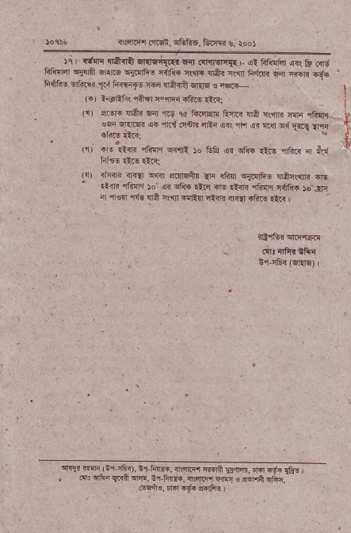
asFr Fr6n, srffi6, &rrr !. ioo)
%). {f,F ^{rffi slE} _{TEr} ^{@.drrq'{{} ,?t!fi.{fu.F _{ffdF} ^{qTrii} Fe @ ^{sjrh! 'd-e} _{{@ {ir} ^{n} ₄ ^{h1ir.} @ IFE r.Ja _{Ff6's} ^{qt{:i} _{Tr} Frnra6 w _{{nffi} ^{qi'6} ts iE.lL
I
r., ^{r,} _{erf} ^{,"+qF@6tq@} m.
_{(i) ilFr4} ^{q6tr} 6{ r.9 tu tu4qi fiftr !r6t rdrF fii ffiI1r f
_{ssi} qr.lF q ^{qr{.:rnB} oRi ar\ fi s? r!] ^{c{rifl!} {,Fr
' (ri _{iF'+iE} ^{qFnq q{,rE} _{)o ee} ^{qr qj!" tio} _{"rftr} ^{:n} fo '.(n2lm5'Fi
^{srFiir} _{A?} ltn sjFrE ^{rfr{afi} @
: .!{m _{cFnie 50 {r} ^{qft6} €.q @ _{It{E} ^{,ifiIl.i} c{ftr )o""rE . ' a@ fj! ^{ri} _{r.4} 6{10 ^{qtft n 4i'r!!aR} I
^{ftF r@ iG'} _{"?i'. !.} i@. ^{n{.F '{.e} _{Fr.} ^{r @} r&,
_{o:} ^{qfirr qz.n} _{w. Er 6@} ^{qc6} _{{w ,} q+]'A qFtn
Fqi._ fr .6{ {.rFr. i

